Linear Regression Summary
In linear regression:
y’ is the predicted label (a desired output) b is the bias (the y-intercept)w1 is the weight of featurex1 is a feature (a known input)

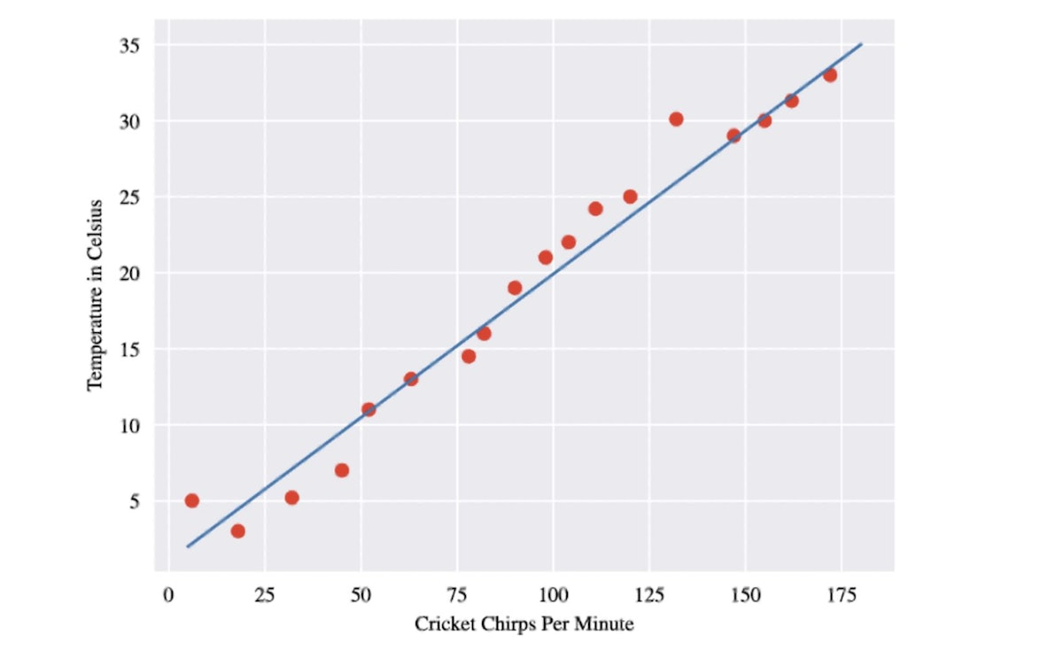

Assumptions of Linear Regression 💫
Normal Distribution
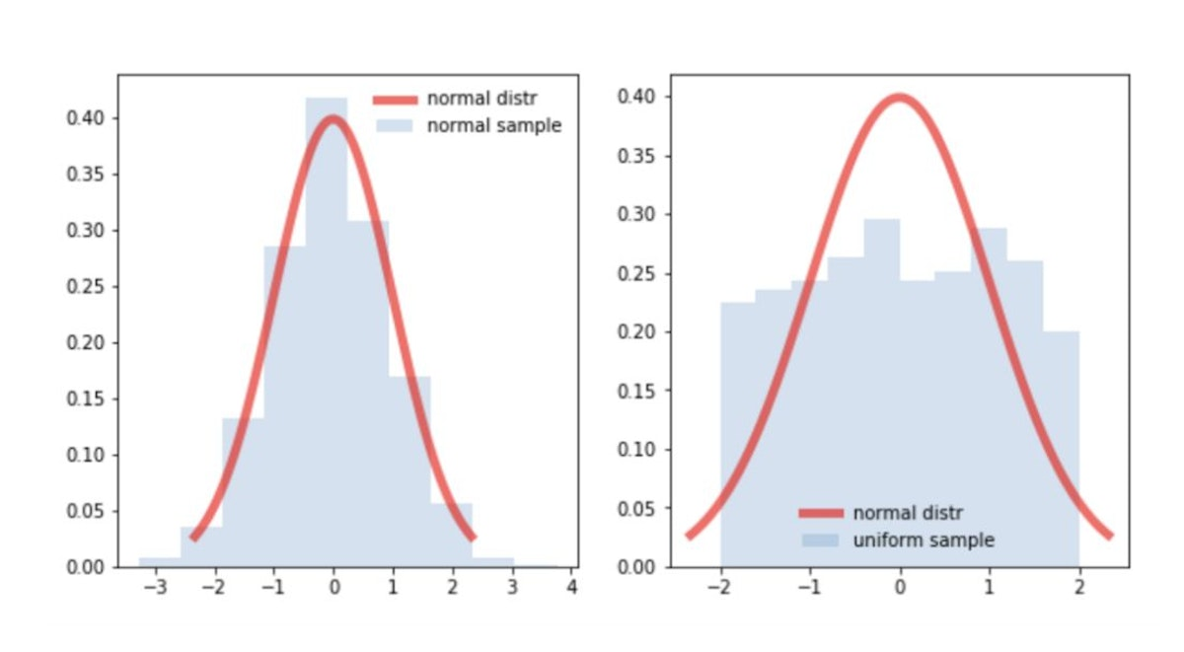
1. Normal distribution of residuals
Normality of residuals. The residuals should be normally distributed.
2. Linearity of residuals
The regression model is linear in parameters. The mean of residuals is zero. Independence of residuals
There are basically 2 classes of dependencies
Residuals correlate with another variable. Multicollinearity is a fancy way of saying that your independent variables are highly correlated with each other.
Residuals correlate with other (close) residuals (autocorrelation). No autocorrelation of residuals. This is applicable especially for time series data. Autocorrelation is the correlation of a Time Series with lags of itself.
3. Equal variance of residuals
Homoscedasticity is present when the noise of your model can be described as random and the same throughout all independent variables. Again, the mean of residuals is zero.
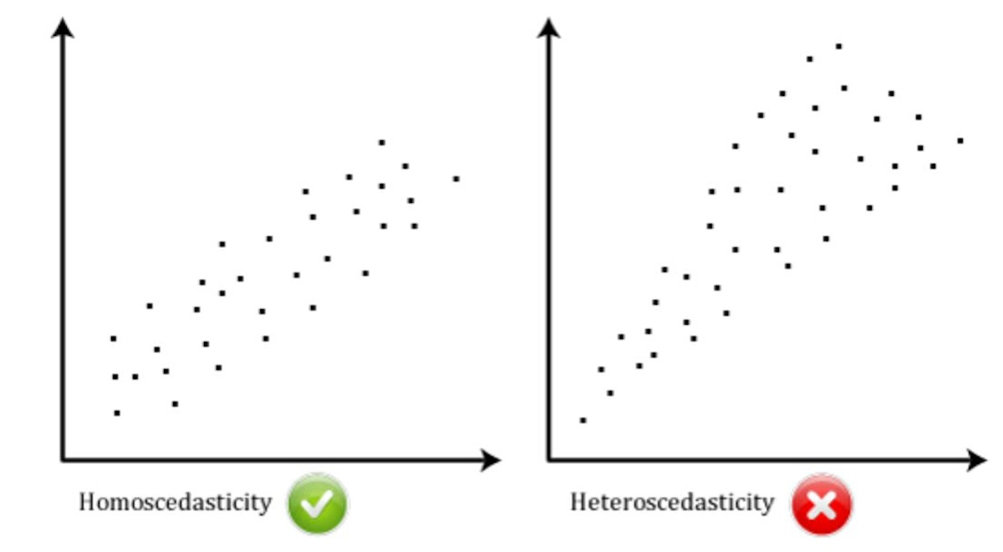

Mean Absolute Error (MAE)
MAE is the average of all absolute errors. The absolute average distance between the real data and the predicted data, but fails to punish large errors in prediction.
Steps of MAE:
- Find all of your absolute errors, xi – x.
- Add them all up.
- Divide by the number of errors. For example, if you had 10 measurements, divide by 10.
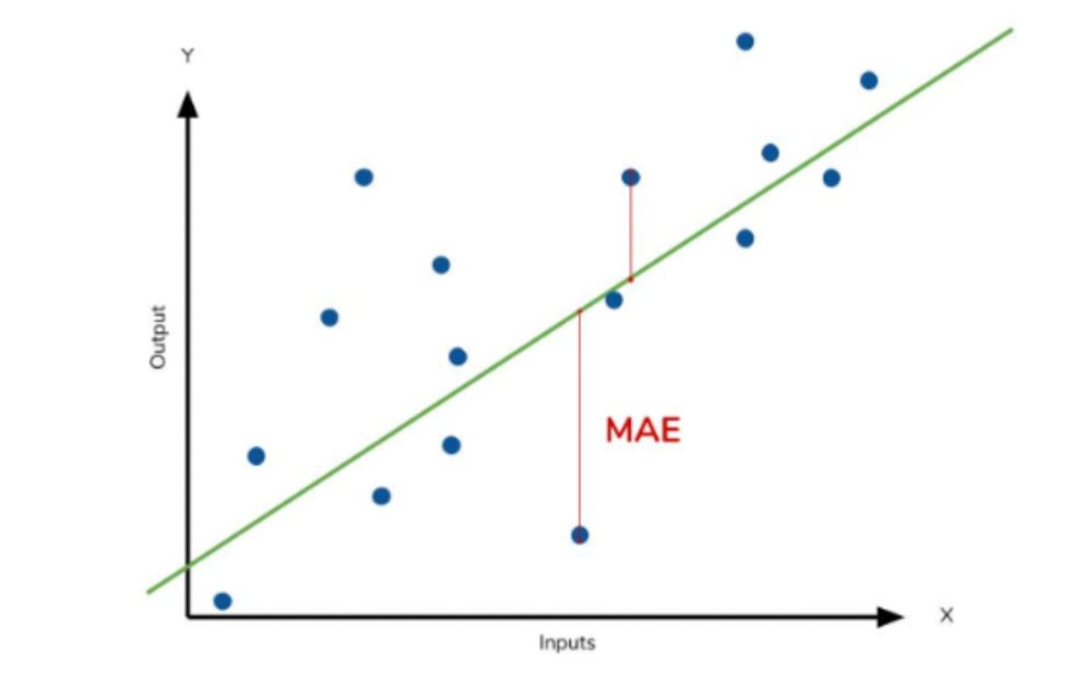

Mean Square Error (MSE)
MSE, measures the average of the squares of the errors— that is, the average squared difference between the estimated values and the actual value.
It is always non-negative, and values closer to zero are better.
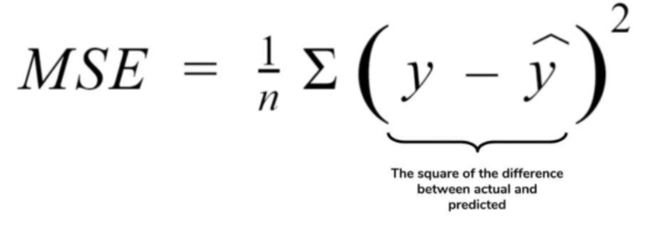
Steps of MSE:
  - Calculate the residuals for every data point.
  - Calculate the squared value of the resilduals.
  - Calculate the average of residuals from step 2.
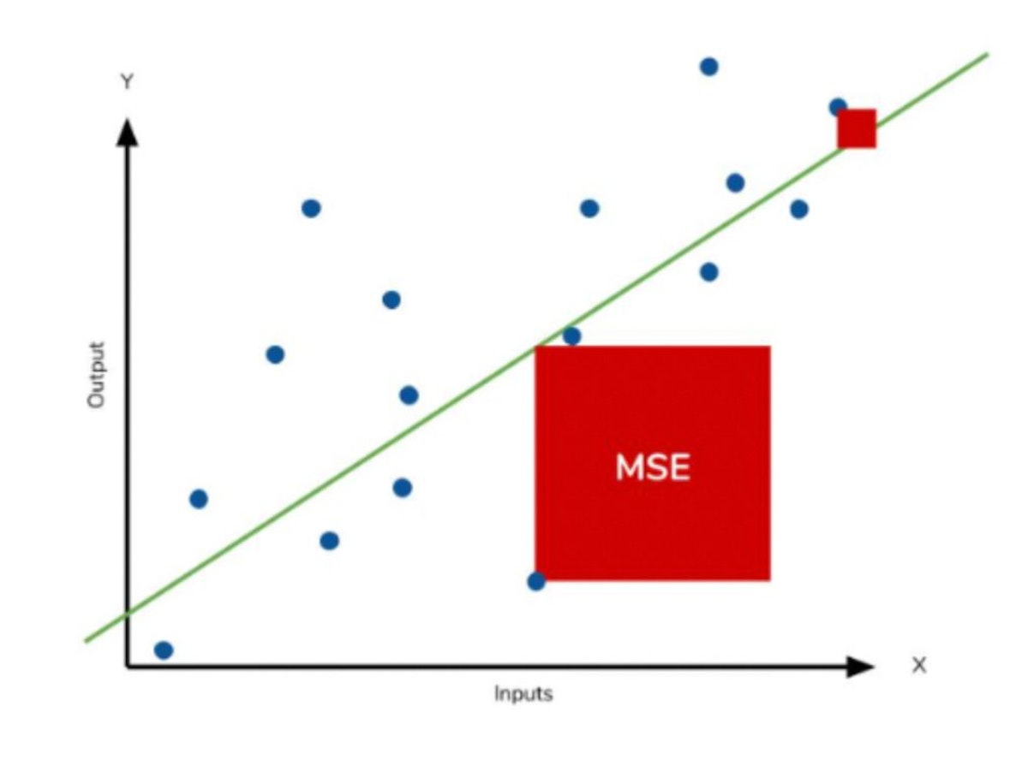

Compare Them
MAE:
    - The idea behind the absolute error is to avoid mutual cancellation of the positive and negative errors.
    - An absolute error has only non-negative values.
    - By the same token, avoiding the potential of mutual cancelations has its price – skewness (bias)cannot be determined.
    - Absolute error preserves the same units of measurement as the data under analysis and gives all individual errors the same weights (as compared to squared error).
    - This distance is easily interpretable and when aggregated over a dataset using arithmetic mean has a meaning of the average error.
    - The use of absolute value might present difficulties in the gradient calculation of model parameters. This distance is used in such popular metrics as MAE, MdAE, etc.
MSE:
    - The squared error follows the same idea as the absolute error – avoid negative error values and mutual cancellation of errors.
    - Due to the square, large errors are emphasized and have a relatively greater effect on the value of the performance metric. At the same time, the effect of relatively small errors will be even smaller. Sometimes this property of the squared error is referred to as penalizing extreme errors or being susceptible to outliers. Based on the application, this property may be considered positive or negative. For example, emphasizing large errors may be a desirable discriminating measure in evaluating models.
    - In case of data outliers , MSE will become much larger compared to MAE. Avoiding the potential of mutual cancelations has its price – skewness (bias)cannot be determined (for MAE).
    - In MSE, error increases in a quadratic fashion while the error increases in a proportional fashion in MAE.
    - In MSE since the error being squared, any prediction error is being heavily penalized.
- The Trade-Off: MSE vs. MAE
- When faced with the decision of which loss function to utilize in your regression problem, you encounter the trade-off between Mean Squared Error (MSE) and Mean Absolute Error (MAE). Each of these options comes with its advantages and considerations, making the choice dependent on the nature of your data and the problem at hand.
- Advantages of Mean Squared Error (MSE):
- MSE, a widely adopted loss function, measures the average of the squared differences between predicted and actual values. It offers faster convergence in scenarios where the error values are relatively small and consistent. The key to its rapid convergence lies in the error amplification mechanism it employs. For larger errors, the squared term magnifies their impact, which accelerates the minimization process during training.
- Limitations of MSE and Handling Outliers:
- However, the strength of MSE can also be its downfall, particularly when dealing with data that contains outliers. Outliers are data points that significantly deviate from the norm and often don’t conform to the overall trend. MSE treats all errors with equal importance, which means outliers have a substantial impact on the loss calculation. This can lead to compromised model performance when dealing with normal data points. In essence, MSE amplifies the influence of outliers, undermining the model’s ability to generalize effectively.
- Advantages of Mean Absolute Error (MAE):
- On the other hand, Mean Absolute Error (MAE) offers an alternative approach to tackling regression problems. Instead of squaring the error terms, MAE takes the absolute value of the differences between predicted and actual values. This attribute makes MAE inherently robust to outliers. Unlike MSE, MAE treats all errors equally, minimizing the impact of outliers on the loss function. As a result, the model learns to prioritize fitting the majority of the data points accurately.
- Choosing Between MSE and MAE:
- To decide between MSE and MAE, it’s crucial to assess the nature of your data. If your dataset includes outliers — data points that don’t conform to the general pattern — it’s advisable to opt for MAE. By treating all errors equally, MAE provides better resilience against the distortions introduced by outliers. Conversely, if your data is relatively clean and without significant outliers, MSE’s faster convergence might offer an advantage.
- Conclusion:
- In the landscape of regression problems, the choice between Mean Squared Error (MSE) and Mean Absolute Error (MAE) as loss functions is pivotal. MSE’s rapid convergence can be an asset, but its susceptibility to outlier influence makes it less suitable for datasets containing anomalies. In contrast, MAE’s robustness against outliers ensures a more balanced training process, ultimately leading to models that generalize better. Understanding the characteristics of your data and the strengths of each loss function is essential in making an informed decision that aligns with your problem’s requirements.

Here's a comparison between MSE, MAE, RMSE, and R^2 score:

1. **Mean Squared Error (MSE):**
- MSE calculates the average of the squared differences between the actual and predicted values.
- It amplifies the effect of large errors due to squaring.
- MSE is not directly interpretable in the units of the target variable.
- It is widely used in practice and has nice mathematical properties.

2. **Mean Absolute Error (MAE):**
- MAE calculates the average of the absolute differences between the actual and predicted values.
- It gives equal weight to all errors.
- MAE is less sensitive to outliers compared to MSE.
- MAE is directly interpretable in the units of the target variable.

3. **Root Mean Squared Error (RMSE):**
- RMSE is the square root of MSE, which provides a measure of the average magnitude of the errors in the same units as the target variable.
- It penalizes large errors more heavily than small errors.
- RMSE is a popular metric for evaluating the performance of regression models, especially when the errors are expected to be Gaussian distributed.

4. **R-squared (R^2) Score:**
- R^2 score measures the proportion of the variance in the dependent variable that is predictable from the independent variables.
- It provides an indication of the goodness of fit of a model.
- R^2 score ranges from 0 to 1, where 1 indicates a perfect fit and 0 indicates that the model does not explain any of the variability in the target variable better than a horizontal line.
- Negative values of R^2 indicate that the model is worse than a horizontal line.

MSE and MAE measure the average error between actual and predicted values, RMSE provides a more interpretable measure of the average error in the same units as the target variable, and R^2 score measures the goodness of fit of the model. Each metric has its own advantages and use cases depending on the specific requirements of the problem at hand.

The impact of MSE, MAE, RMSE, and R^2 score on each other's values can vary based on the specific characteristics of the data and the model being evaluated. Here's a general overview of how they can influence each other:

1. **MSE and MAE**:
- MSE penalizes larger errors more heavily than MAE due to squaring. As a result, if there are outliers or large errors in the predictions, MSE will be higher compared to MAE.
- MAE, on the other hand, treats all errors equally regardless of their magnitude. Therefore, if the errors are relatively small and distributed evenly, MAE may be lower than MSE.

2. **RMSE**:
- RMSE is directly related to MSE because it's the square root of MSE. Therefore, as MSE increases or decreases, RMSE will also increase or decrease respectively.
- RMSE is more interpretable than MSE since it's in the same units as the target variable. However, it may be more sensitive to outliers than MSE because of the squaring effect.

3. **R^2 Score**:
- R^2 score is inversely related to MSE and directly related to RMSE. A lower MSE or RMSE corresponds to a higher R^2 score, indicating a better fit of the model to the data.
- R^2 score also depends on the variability of the data. If the data has high variability, R^2 score tends to be lower, and vice versa. Therefore, the scale and distribution of the data can influence the R^2 score.

MSE, MAE, RMSE, and R^2 score are interrelated, but each provides a different perspective on the performance of the model. The choice of which metric to use depends on the specific requirements of the problem and the characteristics of the data.

